
Foundation Certificate in Higher Education
Module : DOC 333 – Introduction to programming
Module Leader : Mr. Sudarshan Welihinda
Assessment type : Individual Coursework
Topic : Pinky, Inky, Polly game
Student details :
Student ID | Student Name
20221804 | Muhammed Saad Mazhar

Acknowledgement
• I would like to take this opportunity to express my gratitude and appreciation for the support and guidance that I have received while preparing this coursework report.
• Firstly, I would like to thank Mr. Sudarshan Welihinda and Ms. Tharushi Amarasinghe, for their invaluable guidance and insights throughout the assignment. Their expertise and teaching skills have been fundamental in shaping my knowledge and understanding of the subject matter.
• I would also like to express my gratitude to my batchmates for their contributions, feedback, and collaboration during the development of this assignment. Their support and constructive criticism have been significant in improving the quality of this report.
• Lastly, I would like to extend my gratitude to my family and friends for their unwavering support and encouragement throughout this assignment. Their encouragement has been a source of motivation for me to keep working hard.
• Thank you again for your support and encouragement.
pg. i
Table of Contents
Acknowledgement ........................................................................................................................................ i Table of Figures............................................................................................................................................. ii List of tables.................................................................................................................................................. ii Problem understanding................................................................................................................................1 Algorithm......................................................................................................................................................2 Python code..................................................................................................................................................4 Test cases......................................................................................................................................................5 Screenshots of test cases .............................................................................................................................6
Table of Figures
Figure 1 - Python Code (1) ............................................................................................................................4 Figure 2 - Python code (2).............................................................................................................................4 Figure 3 - Test case (1)...................................................................................................................................6 Figure 4 - Test case (2)...................................................................................................................................6 Figure 5 - Test Case (3) ..................................................................................................................................6 Figure 6 - Test Case (4 ...................................................................................................................................6 Figure 7 - Test Case (5) ..................................................................................................................................7
List of tables
Table 1 - Rules...............................................................................................................................................1 Table 2 - Test Cases........................................................................................................................................5
pg. ii
Problem understanding
This game is a simple implementation of the rock-paper-scissors game, with a few modifications. Instead of using rock, paper, and scissors, the game uses three characters named pinky, inky, and polly. The player competes against the computer, with each making a choice between the three characters. The game follows the traditional rules of rock-paper-scissors: pinky beats inky, inky beats polly, and polly beats pinky. The winner of each round is determined based on the comparison of the player's and the computer's choices, with the score being tallied after each round. The game continues until the player decides to end it. At the end of the game, the winner is determined based on who has the higher score. The game is easy to understand and play, making it a popular choice for quick and simple entertainment. This has a few rules, they are ;
• Pinky > Inky
• Inky > Polly
• Polly > Pinky
Player choice | Computer choice | Rule | Output | Else
Pinky | Inky | Pinky > Inky | Computer won | Player won
Inky | Polly | Inky > Polly | Computer won | Player won
Polly | Pinky | Polly > Pinky | Computer won | Player won

Table 1 - Rules
pg. 1
Algorithm
Step 1 – Start
Step 2 – Initialize variable
Step 3 – Open a list of choices with Pinky, Inky & Polly
Step 4 – Initialize the player score to zero
Step 5 – Initialize the computer score to zero
Step 6 - Input name of the player.
Step 7 – Start a loop until the player decides to End the game
Step 8 – If player enters ‘E’, break the loop and end the game
Step 9 – If player enters something other than (Pinky, Inky, Polly), print an error message and continue the loop
Step 10 – Computer chooses a random choice from the list choices (Pinky, Inky, Polly) Step 11 – if the choice of the computer and player is equal then print, “It’s a Tie” Step 12 – If player choses Pinky and computer choses Inky, Player wins. Step 13 – If player choses Inky and Computer choses Polly, Player wins. Step 14 – If player choses Polly and computer choses Pinky, Player wins. Step 15 – else computer wins.
pg. 2
Step 16 – If player wins, award 1 point for the player.
Step 17 – If Computer wins, award 1 point for the computer.
Step 18 – After every round of game, display player name with the score & computer name with the score.
Step 19 – Display the winner.
Step 20 – Continue the loop until the player ends the game.
Step 21 – When the player ends the game
Step 22 – Calculate the final score of the computer as well as the player.
Step 23 - When the player ends the game, display the computer name and the final score of the computer.
Step 24 – and display the player name and player score.
Step 25 – If player score is greater than computer score, then display “player wins” (Player name).
Step 26 – If computer score is greater than player score, then display “Computer wins.” Step 27 – If computer score is equal to player score, then display “Tie”.
Step 28 - End
pg. 3
Python code
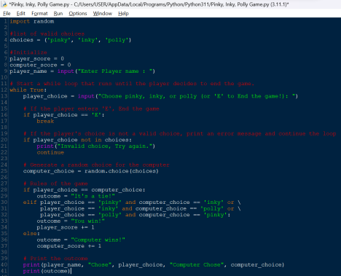Figure 1 - Python Code (1)
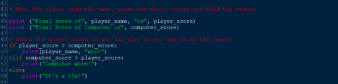Figure 2 - Python code (2)
pg. 4
Test cases
Test Case Number | Inputs | Expected output | Points | Remark
1 | Computer : Pinky Player : Inky | Computer wins | Computer = 1 | Test case pass
2 | Computer : Inky Player : Polly | Computer wins | Computer = 1 | Test case pass
3 | Computer : Polly Player : Pinky | Computer wins | Computer = 1 | Test case pass
4 | Computer : Inky Player : Pinky | Player wins | Player = 1 | Test case pass
5 | Computer : Polly Player : Inky | Player wins | Player = 1 | Test case pass
6 | Computer : Pinky Player : Polly | Player wins | Player = 1 | Test case pass
7 | Computer : Pinky Player : Pinky | Match Tied | 0 | Test case pass
8 | Computer : Inky Player : Inky | Match Tied | 0 | Test case pass
9 | Computer : Polly Player : Polly | Match Tied | 0 | Test case pass
10 | Computer : Polly Player : ABC | Invalid choice, try again | 0 | Test case pass

Table 2 - Test Cases
pg. 5
Screenshots of test cases
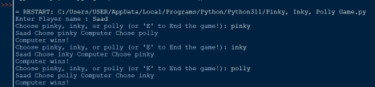Figure 3 - Test case (1)
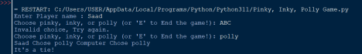Figure 4 - Test case (2)
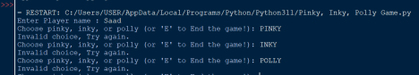Figure 5 - Test Case (3)
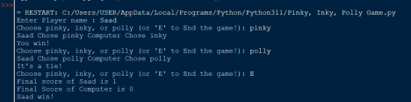Figure 6 - Test Case (4
pg. 6
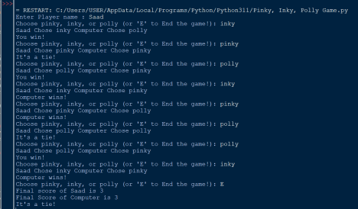Figure 7 - Test Case (5)
pg. 7

